Notice of Conventions

Republican Party of Brazos County

County Convention
June 13, 2020, 9:30 AM
Best Western Premier
1920 Austin's Colony Parkway, Bryan, Texas 77802.
For more info email info@BrazosGOP.org
or call 979.268.2308

State Convention
July 16-18, 2020, 9:00 a.m.
George R. Brown Convention Center
1001 Avenida de las Americas
Houston, Texas 77010

For more information on Texas Republican Conventions visit: https://www.texasgop.org/convention/

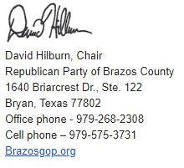
May 28, 2020

